'संध्या - Sundown at Puri'
The story telling sculptures of Jagannath Temple, Odisha

By Vrinda Chadha
(Odissi Dancer & Arts Educator)

INTRODUCTION

When I started learning Odissi at the age of six under the tutelage of my Guru, renowned Odissi exponent Padmashri and SNA awardee, Smt. Ranjana Gauhar, I was mesmerised and struck by the apsara-like look that she would so gracefully embody. Over the years my Guru always emphasised on the lyrical & sculpturesque look of Odissi dance, which she explained, found its roots in Bharat Muni’s Natya Shastra. This text stated that Odhramagadhi (An Eastern performing artform of the yore from which Odissi eventually evolved) has the Kaishiki Vritti (or character). Which means that Odissi is a dance full of Lasya (characterised by the feminine, delicate element). My Guru would often point out that Odissi is a form which is rich in substance and intensity of emotions, a beautiful and rare synthesis of sensuousness and devotion. While accompanying my Guru for dance programs to Odisha I saw for myself how the Sculptures in the temples of Orissa come alive in the movements as the rhythm of dance is captured in thousands of images adorning these temples. Appreciation for this sculpturesque quality that my Guru embedded in me from a young age is perhaps what I find to be the most striking feature of Odissi. It is what triggered and inspired me to work on:
'संध्या - Sundown at Puri'
A descriptive photo series recreating the dancing sculptures of Odissa’s Jagannath temple, Puri.
CREDITS:
Concept, execution and writing - Vrinda Chadha
Photography and Design - Innee Singh
Reference material - Sketches from the book 'Odissi Dance' by, scholar, author and researcher, late D.N. Pattnaik
CONCEPT
Looking at the reference sketches from the book ‘Odissi Dance’ and recollecting memories with my Guruji of sculptures decorating the walls of Jagannath Temple in Puri Odisha, I couldn't help but wonder if they denoted meaning or were carved simply for aesthetic appeasement. Either way, their bold and sensuous presence, so close to the deities, is the freedom I associate with dance and art contrary to the rigid covers of pseudo morality we hide everything in today. This photo series invoked a character shade in each picture for me. And so, below is a picture wise breakdown that follows, wherein I have tried to perceive every dancing sculpture with its own personality and aesthetic questioning, set in the current complex cultural fabric of the dance world today. Please join me in this humble attempt to visually travel back in time while attempting to move forward in thought.
THE PHOTO SERIES – PART 1

- 'The Observant Novice'
The first dancing pose made me think of the curious and watchful observer in every artist attempting to decode the hypocrisies of a strange world. To willingly or unwillingly finding their place as they take the first step - Engaged yet disengaged. Coping with the very fundamental angst of existence and all the overwhelming emotions it brings along. These then translate into their art and showcased for the rest of the world to see.
Odissi trivia for dancers:
> The torso is in Dakshyachala position
> The left hand in Shukanchanchu and right in Hamsasya Mudra
> The feet are in a wide Tribhangi position
> Eyes in Sachi Drishtibheda and Neck in Tirascina Grivabheda
> Oddly this pose does not raise that hand over the head which is to the side of the hip bend. Infact it uses the opposite. Creating an unusual body position.

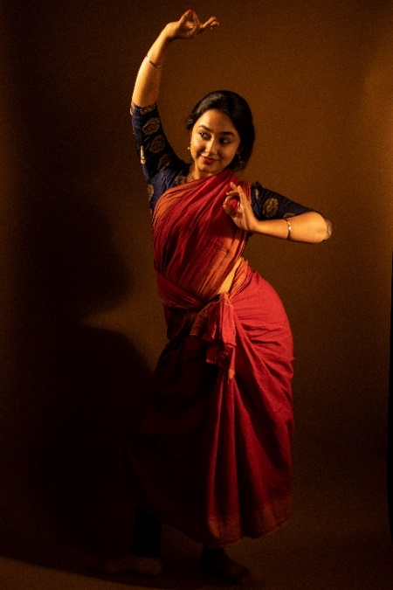
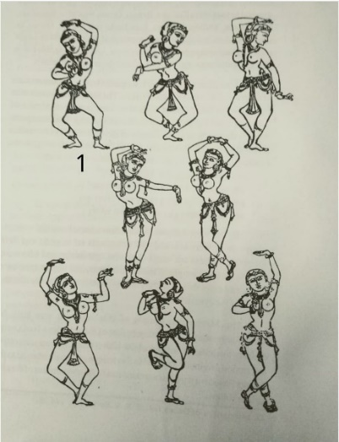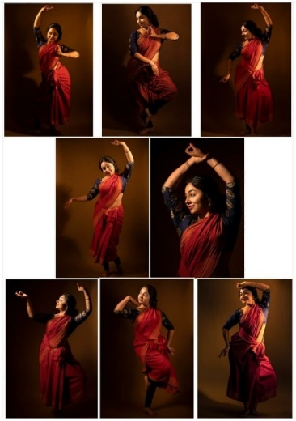
- 'The prepossessing and unfeigned'
Dancing Sculptures of Jagannath Temple Puri in Odisha often exude an honest and sincere prepossessing beauty. Their untouched innocence and piercing naivety seem to me a reflection of the artist who created them. Often times dance challenges one to navigate and shed through the inner walls built over our true selves. Usually, one is unaware of their presence & in order to come closer to the ‘self’ dance demands that we shed such layers. Leaving no room for dishonesty. Perhaps art requires us to recognise authenticity within and consequently adopt it in our worldview.
The artist’s work seems most appealing when this unfeigned, earnest, childlike genuineness takes over them while expressing on stage or otherwise. No amount of external glamour or glitz compares to this quality of vulnerability induced by art. A quality independent of and beyond body shapes, skin tones, genders, social, economic backgrounds. To think that art allows such an inclusive space & freedom, to anyone willing to put in heart and effort, is truly a liberating thought.

Odissi trivia for dancers:
> The right hand is in Dolahasta and left in Shukanchanchu Mudras.
> The foot position is of Nupur Paadabheda (left toe touching the right ankle while body is bent in tribhang)
> Interestingly the neck is tilted away from the hand near the chin, giving the dancer a coy look as she sees in the opposite direction.

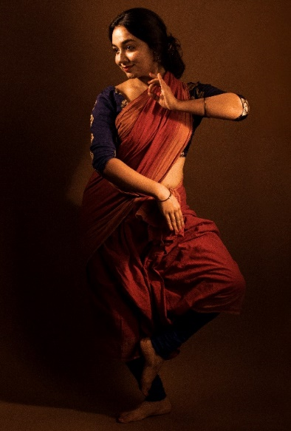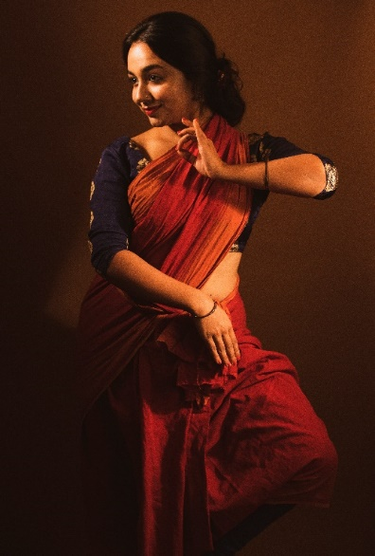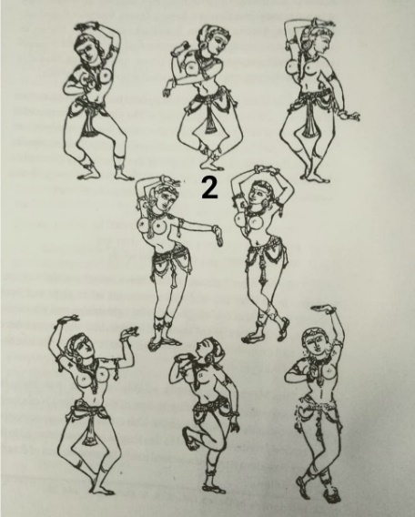

- 'The Contemplative'
Often times the artist's job is to present their work in such a way that it impacts the audience without making the effort put into the process evident. A touching painting, haunting song, powerful dance etc, have to their credit years of practice. This built-up, leading to the final presentation, is inconspicuous. It is transformed subtly and gracefully by the artist. The practitioner of an artform is privy to the multiple levels that need crossing in order to reach a polished finality. Which when looked at closely is merely a start, a drop in the ocean. The process of growth is ever evolving and never ending.
Dancers often find themselves contemplating when divided between the classic struggle of head and heart. The head constantly focussing on perfecting those tiny technical details while the heart urging to give in and letting go. An agreement is arrived at only when the body has thoroughly imbibed in its muscles every movement, thus leaving automatic room for the heart to leap, fly and indulge in the magical joy of a piece progressing from - the piece learnt mechanically once upon a time to the piece truly becoming the dancer’s own identity for a fleeting moment because it comes from someplace within.
Odissi trivia for dancers:

> Both hands are in Hamsasya Mudra
> Feet in Kunchita Paada (left heel raised)
> Torso in Bamachala position (ribcage shifted to left side)
> Head in Dhuta Shirobheda
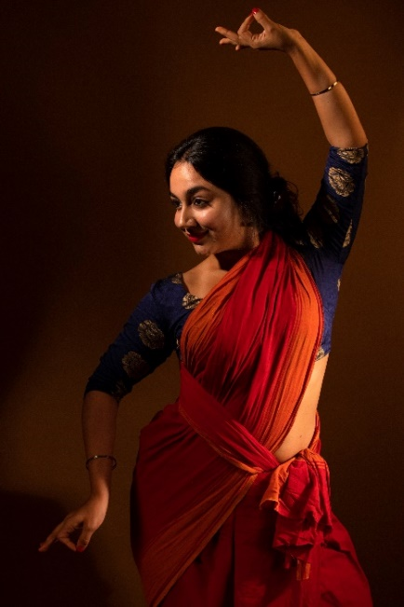
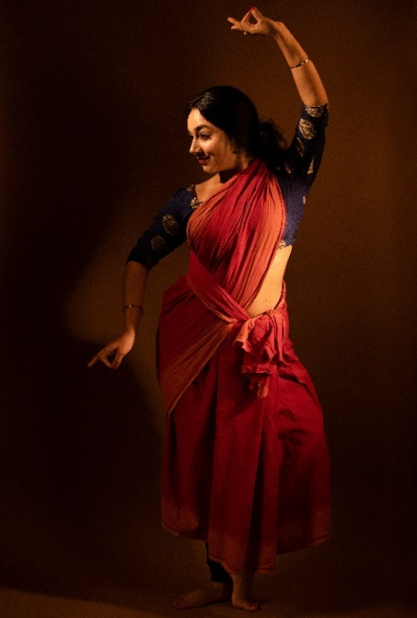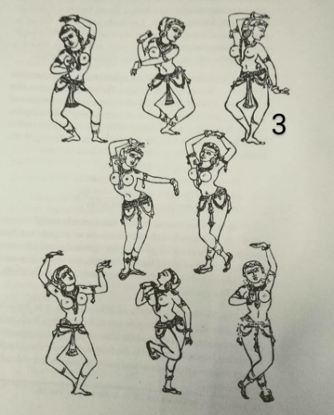

- 'The Playful and Blithesome'
Sometimes we find ourselves go through a three sixty mood shift before and after dancing. As if getting on a train at a grim cold place and journeying suddenly to the sunny tropics. While the feeling of heaviness may still remain, one becomes indifferent to its weight upon losing the self in movement. It is then channelled effectively through emotions (storyline-based pieces) or in energy (power packed technical pieces) or both.
Usually the end of practice leaves one feeling spirited and reloaded. A feeling of being able to take on anything. Contrary to the drained feeling one associates with an intense workout. The rush of dance is unmatched and creates hunger for more. Satiated only once the dance begins again next time. An infinite cycle. Even a lifetime seems less.
Odissi trivia for dancers:

> Right hand in Dolahasta and left in Hamsasya Mudra
> Left heel is raised and body is in abhanga position
> Eyes in Sachi Drishtibheda and Neck in Tirascina Grivabheda
> Torso in Bamachala position (ribcage shifted to left)

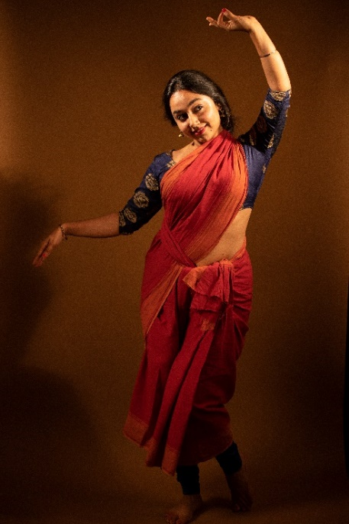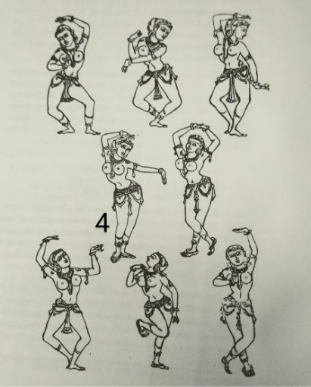

VIEWS OF THE FELLOW COLLABORATOR
THE PHOTOGRPHER - MR. INNEE SINGH

Q1. As a photographer how did you use lights and set design to create the effect of sculptures?
A1. “I mostly used warm tones within the camera to create the ambience. The lights I used were minimal and yet powerful enough so that the pictures would not look noisy and details will remain intact. There was also use of interesting backgrounds which had grany textures in hues of browns along with dim lights to give a sunset effect.”
Q2. Were there any challenges faced while trying to make the person in frame resemble a temple sculpture while shooting in studio.
A2. “I did not feel much need to correct the person since it was her concept and she very well knew what the pose was. Benefits of working with a dancer. She had done her homework well.”
Q3. Any thoughts you'd like to share about this shoot with the readers?
A3. “I enjoy working with artists who create new visuals and give me challenges to work with more creative lights and produce work that is different from usual dance projects. It keeps the interest alive.”

THE PHOTO SERIES – PART 2 (Continued)

- 'The Dreamy Damsel'
Recurring depiction of a woman in storylines is of dreaming and romanticizing over the man she loves. A forlorn lover always waiting for a union with him. While that mood may be a classic one and enjoyable now and then, I can't help but wonder what the modern woman would dream of? Maybe making the first move? Or having an unconventional gender preference? Or an unromantic dream altogether?
An ambitious one instead, a dream of a better world, a more equal world. And so, this ‘Dreamy Damsel’ contemplates that while it may be true that male artists have it hard due to the pressures of gender stereotypes in the dance field, one can't at the same time dismiss the struggles of woman in this field either. The fabric of an orthodox patriarchy is what she's unfortunately been compelled to weave herself in. Times have changed though. She dreams to tear right through this stifling fabric. She dreams for her skill & art to be noticed over her exterior & demeanour. A dream of emancipation, so limitless it consumes her & empowers her to believe she can do anything, that she can take on the whole world. And so, she dreams of a world so equal even for him as it could be for her. A new romance perhaps!
Odissi trivia for dancers:

> The feet are in Dhanupada (right foot heel raised, crossed infront of left)
> Torso Dakshyachala position (Ribcage shifted to right)
> Both arms are raised above the head

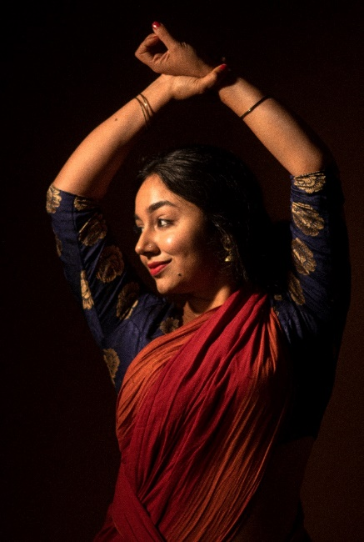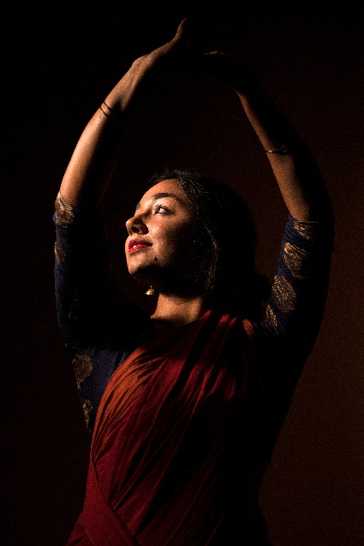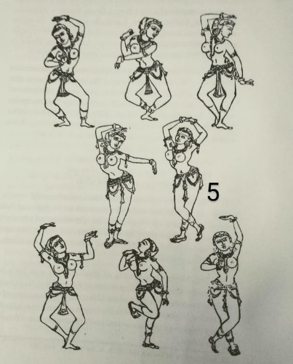

6. 'The seeker'
Words written, spoken or thought are often the bricks of conceptual buildings, tools used on our quest for knowledge. However verbal language is limiting at times, and so the body emerges as the ideal vehicle for truth. It is honest and fills in the indescribable, while our speech defines the concreteness of an idea. In some ways it seems that the two together complete each other. Be it words or dance, we seek to feel and convey a deeper meaning through them. The expectation of what one will discover in a dance piece is different almost every time it is practiced. Just as it happens when re-reading a text. A new meaning, perspective or interpretation of the same piece each time it is done, arouses a feeling of subjectivity.
We see words often being employed without thought today, carelessly thrown around. The question is - would we be so neglectful of art too? Pursue it without reflection? Aren't we going to seek more from it? Explore its possibilities and resist its stagnation? The fear of quieting ideas, speech and the fear of invisible boundaries finding their way around art and all knowledge, has been braved against all through history. For the very essence of art is to be a seeker of truth & knowledge, to be real and free just as words should be.
Odissi trivia for dancers:
> Right hand in Hamsasya & left in Chatura hasta mudra
> Head in Utkhipta Shirobheda
> Torso Dakshyachala position
> Feet in Suchi Padabheda
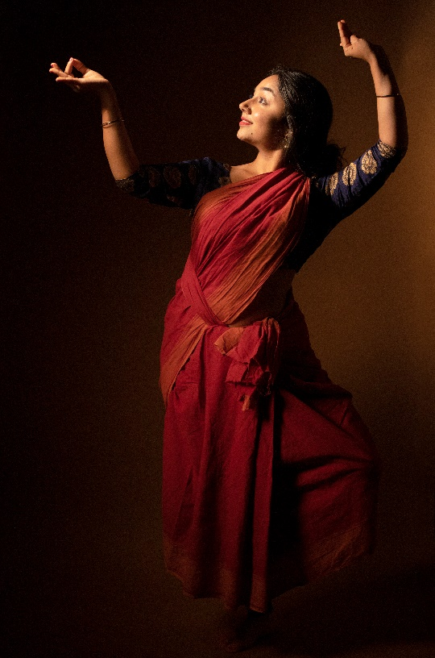

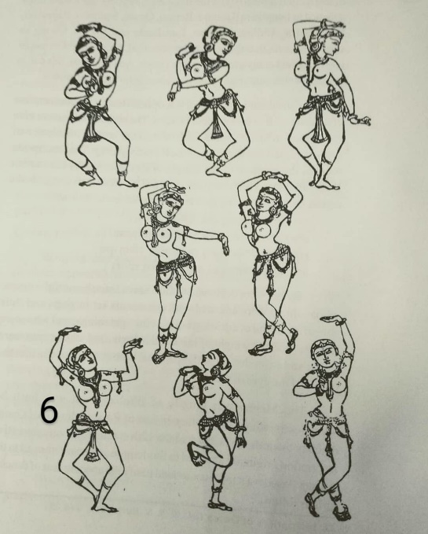
- 'The one with the pride'
Often our sense of self blurs, captures and occupies the room needed to be left for reflection, reason and ability to accommodate counter narratives to ours. The fine line between self-worth and haughtiness is faint. If dangerously crossed it starts to resemble a suffocating solid block of black with no room for creativity or bloom. Only darkness and muck bouncing off the walls it is trapped in. The undoing of an artist is in his/her arrogance of dismissing any other creative voice other than his/her own. The muck then trickling down to their body of work and, as a consequence, averting audiences because in art there's no room for deception.
One could extend the same thought to a society's ruination if it becomes aggressively arrogant and unable to accept counter narratives or criticisms. Halting all creative processes of growth. Breeding more filth in its toxic gloom.
In the infinite vastness of universes and existences, what will we account ourselves for? Divided and consumed in the self, ego and its dictates or united in coexistence, multiple voices, views, open-mindedness and love?
Odissi trivia for dancers:
> Feet in Bandhani Paada (right foot curled behind left knee)
> Utkhipta head position (face moves diagonally up)
> Torso in Dakshyachala position (ribcage shifted to right)
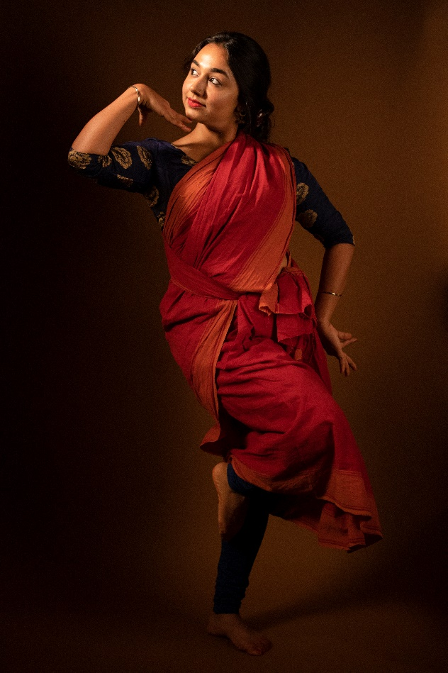 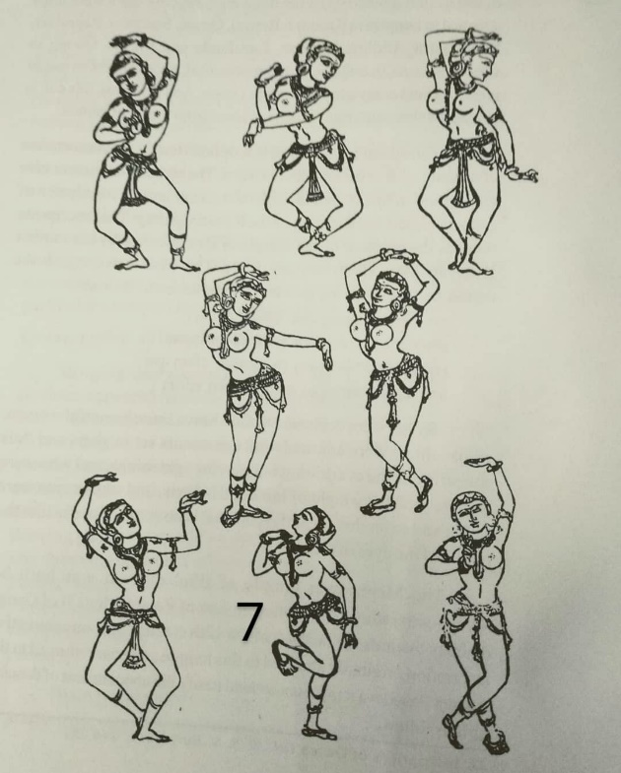

- 'The Resolute'
There's never one way to do something.
There's always room to counter inaction.
There's always a why not? To a why. A 'Yes I can' to a 'No'.
There's always a beautiful dream. Always thorns on arduous paths towards realising it.
There's always a fight to carry on. Always an easy way out.
There's always morals, conscience, hope & action. Always turning a blind eye.
There's NEVER one way to do something.
Unwavering, let's start somewhere?

Odissi trivia for dancers:

> The torso in Dakshyachala position
> The left hand in Shukanchanchu and right in Hamsasya Mudra
> The feet in Dhanu Paada (heel raised and crossed infront of the other flat foot). This last pose is similar to the first except the feet positioning is changed.

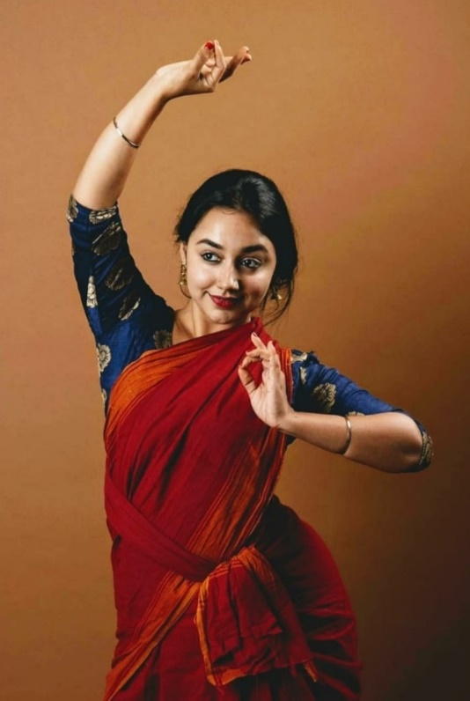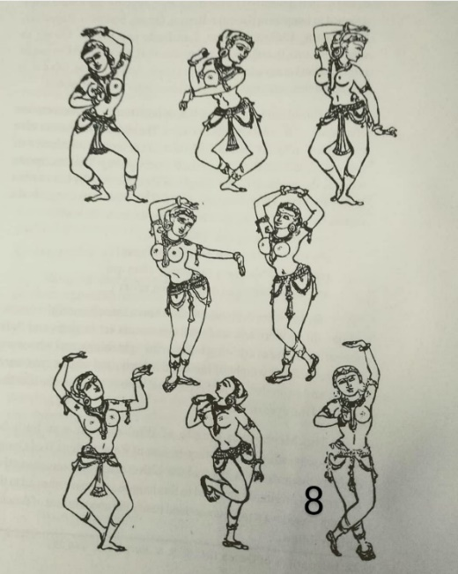
CONCLUSION
“Creating! that is the great salvation and freedom from suffering, and life's alleviation” - Friedrich Nietzsche (Late German Philosopher and Cultural critic)
This final quote sums up the quest of all artists - be it in the times when these sculptures were actually built or us today trying to emulate them and building a dance vocabulary. The need to create is what brings excitement, hope and freedom. It is the basis of why we do what we do. To bring an idea, concept, thought, artwork into existence is truly magical! And that closing thought brings us to the end of 'संध्या - Sundown at Puri'. A descriptive photo series recreating the dancing sculptures of Odissa’s Jagannath temple, Puri.

